Project Design Phase-II
Technology Stack (Architecture & Stack)

Date | 18 June 2026
Student Name | Ch.Sai Shruthi
Project Name | ShopEz
Maximum Marks | 4 Marks

Technical Architecture:
The Deliverable shall include the architectural diagram as below and the information as per the table1 & table 2
ShopEz-Online Shopping Platform
Guidelines:
Include all the processes (As an application logic / Technology Block)
Provide infrastructural demarcation (Local / Cloud)
Indicate external interfaces (third party API’s etc.)
Indicate Data Storage components / services
Indicate interface to machine learning models (if applicable)
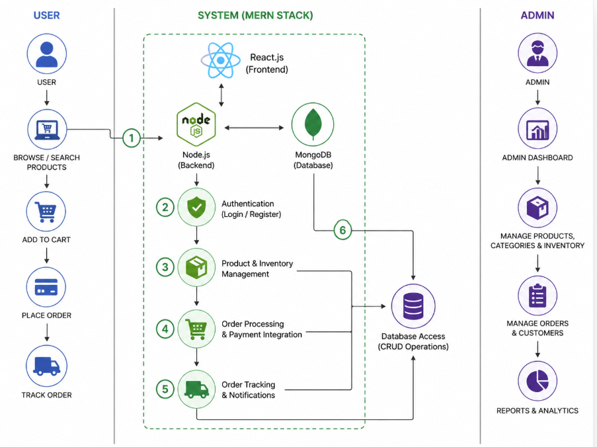

Table-1 : Components & Technologies:
S.No | Component | Description | Technology
 | User Interface | User interaction screens | HTML, CSS, JavaScript, React Js etc.
 | Application Logic-1 | User Authentication & Authorization | Node.js, Express.js, JWT
 | Application Logic-2 | Product Catalog & Search | Node.js, Express.js
 | Application Logic-3 | Cart, Orders & Admin Management | Node.js, Express.js
 | Database | Stores users, products, carts, orders | MongoDB
 | Cloud Database | Cloud-hosted database | MongoDB Atlas
 | File Storage | Product images and assets | Local Storage / Cloudinary
 | External API-1 | Payment Integration | Razorpay API / Stripe API
 | External API-2 | Email Notifications | Nodemailer / Gmail SMTP
 | Machine Learning Model | Not Used | N/A
 | Infrastructure (Server / Cloud) | Application Deployment | Local Server, Render, Vercel

Table-2: Application Characteristics:
S.No | Characteristics | Description | Technology
 | Open-Source Frameworks | ShopEZ is built entirely using open-source frameworks. The frontend uses React.js for building UI components and Vite as the build tool. The backend uses Express.js for REST API development and Mongoose as the ODM for MongoDB. All libraries used are freely available on npm. | React.js, Vite, Express.js, Mongoose, Node.js, Axios, React Router DOM
 | Security Implementations | ShopEZ implements JWT (JSON Web Token) based authentication for secure login sessions. Passwords are hashed using bcryptjs before storing in MongoDB. Role-based access control (RBAC) is used to separate User and Admin permissions. All protected API routes are secured using middleware that validates the Bearer token on every request | JWT (jsonwebtoken), bcryptjs, RBAC Middleware, HTTPS)
 | Scalable Architecture | ShopEZ follows a 3-Tier Architecture: Presentation Layer (React frontend), Application Layer (Node.js + Express REST API), and Data Layer (MongoDB). The backend is stateless and RESTful, making it easy to horizontally scale by adding more server instances. MongoDB supports horizontal scaling through sharding. | 3-Tier Architecture, RESTful API, Stateless Backend, MongoDB Sharding, Modular MVC Pattern
 | Availability | ShopEZ is designed for high availability using a decoupled frontend and backend. The React frontend can be deployed on CDN-based platforms like Vercel or Netlify for 99.9% uptime. The backend can be deployed on cloud platforms like AWS EC2 or Render with auto-restart using PM2 process manager. MongoDB Atlas provides cloud-hosted database with automatic failover and replication. | MongoDB Atlas Replication, PM2 Process Manager, Vercel/Netlify CDN, AWS EC2, Nodemon (Dev)
 | Performance | ShopEZ is optimized for performance using lazy loading of product images, pagination (12 products per page) to reduce API response size, and Vite's fast HMR (Hot Module Replacement) for development. Axios is used for efficient HTTP requests. MongoDB indexes on frequently queried fields (email, category) speed up database lookups. React's virtual DOM minimizes unnecessary re-renders for a fast user experience. | Vite Build Optimization, React Virtual DOM, MongoDB Indexing, Image Lazy Loading, Pagination, Axios HTTP Client

